**Exercises Selection**

**Exercise 1**

Write a program that allows the user to test whether a number is a triple.

 

**Exercise 2**

Write a program that reads the year of birth and then prints whether the user is an adult (at least 18 years old) or not. If someone turns 18 this year, you may also consider that person to be an adult.

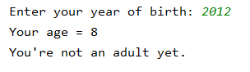 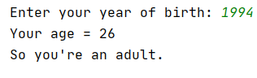

**Exercise 3**

Write a program that allows the user to search for the smallest of 3 numbers.

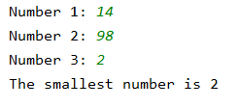

**Exercise 4**

Write a program that allows the user to test if it is possible that one of the three numbers he reads is the sum of the other two numbers.

|  |  |
| --- | --- |
|  |  |

**Exercise 5**

Write a program that allows the user to test whether a positive number greater than 0 ends with a specified final digit.

When the entered number is negative, you will give a message that the test will not be performed.

|  |  |
| --- | --- |
|  |  |
|  |  |

**Exercise 6**

Write a program in which you declare three boolean variables (is_morning, is_mother, is_asleep) that you also give a value.

Then write the code to decide if you need to answer your mobile phone, according to these rules:

* You normally answer your phone except in the morning, then you only answer if it's your mother.
* When you're asleep, you never answer the call.

Test your program by changing the three variables a number of times!



**Exercise 7**

Write a program that prints the larger of two numbers. If a numbers is negative, then you use the opposite value. Example -5 🡪 5

But: if both numbers are divisible by 5, then you have to print the smaller of both numbers.

If both numbers are equal then the answer is just 0.

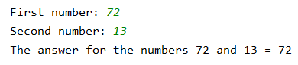

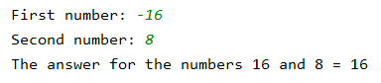

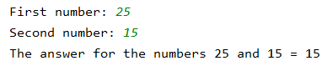

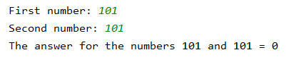

**Exercise 8**

Write a program that allows you to judge whether a party is *stupid*, *good* or *fantastic*.

This depends on the number of bottles of wine and the number of pizzas.

* The party is good if there are at least 5 pizzas and 5 bottles of wine
* The party is fantastic if on top of that the number of pizzas is double the number of bottles of wine (or vice versa)
* Otherwise, it's a stupid party.

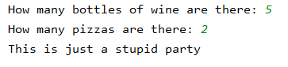

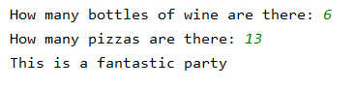

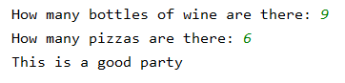

**Exercise 9**

Read in three numbers a, b, and c, all equal to 0, 1, or 2.

Now determine the test result and print it out.

* If the three numbers are equal to 2, then the result is 10.
* If all three are equal but not equal to 2 then the result is 5.
* In the other case: if the numbers b and c are different from a then the result is 1. In all other cases the result is 0.

|  |  |
| --- | --- |
|  |  |

**Exercise 10**

Write a program to determine whether two integers are **both OK** or not.

They are OK if

* they are both between 30 and 40 (inclusive)
* they are both equal to one of the following numbers: 65, 72, 83, 90.

|  |  |
| --- | --- |
|  |  |
|  |  |

**Exercise 11**

A person's BMI (body mass index) is calculated as follows:

$$\frac{weight}{length ²}*10000$$

The value of the BMI is decisive to judge the weight of an (adult) person:

* BMI < 18 underweight
* 18 ≤ BMI < 25 normal weight
* 25 ≤ BMI < 27 slightly overweight
* 27 ≤ BMI < 30 moderate overweight
* 30 ≤ BMI < 40 obese
* 40 ≥ BMI sickly obese

Create a program that asks for your weight and height and shows the BMI and the conclusion.

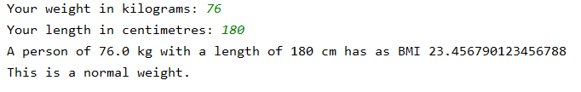

**Exercise 12**

The scouts divide their members into groups they call sections. On the basis of age, the scouts are divided into 4 groups.

* Boys/girls from 6 to 7 (included) are Beavers
* Boys/girls from 8 to 10 (included) are Cubs.
* Boys/girls from 11 to 13 (included) are Scouts.
* Boys/girls from 14 to 18 (included) are Explorers.
* Boys/girls 18 older than 18 are assumed to be Leaders.

Create a program that asks for your age and uses it to determine the scouts section.





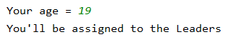

**Exercise 13**

Rock Paper Scissors is a game for 2 players. Players simultaneously choose one of the options rock, paper or scissors.

Rock breaks scissors, scissors cuts paper, paper covers rock. If both players make the same choice, it's a tie.

Define the choice of the computer itself in your program. Let the player choose one of the three options Rock Paper Scissors and then decide who wins.

